The installation instruction of Door lighted Sills

The following parts are included in the kit:

For 4 Doors Use:
4 x door sills with LED 2 x wire set 6 x stripping quick
lighted panel & magnetic splice connector
control switch
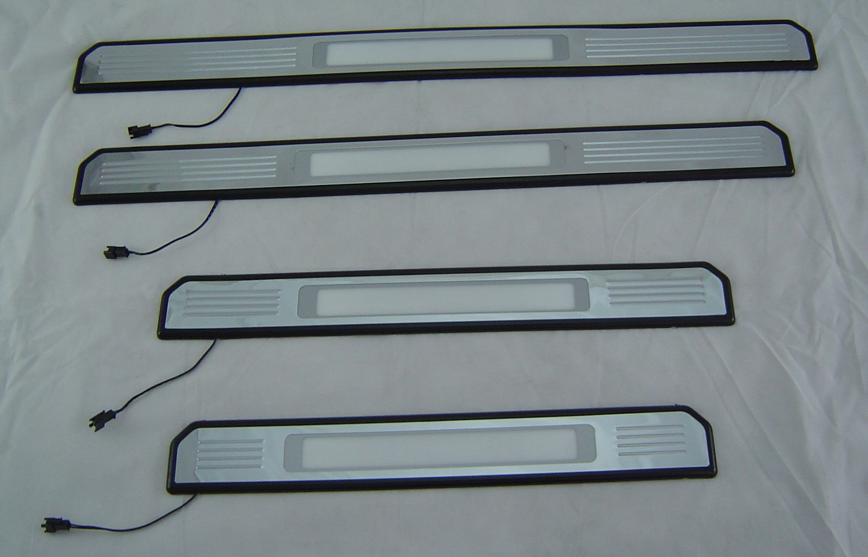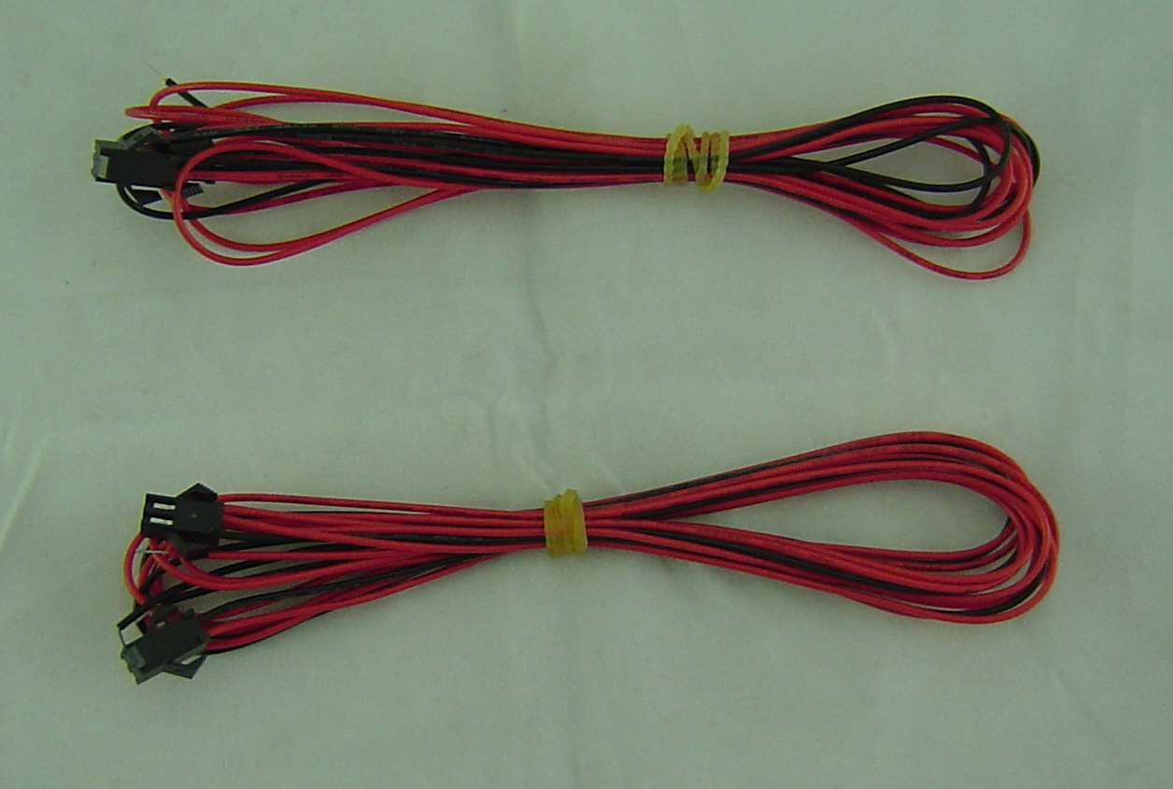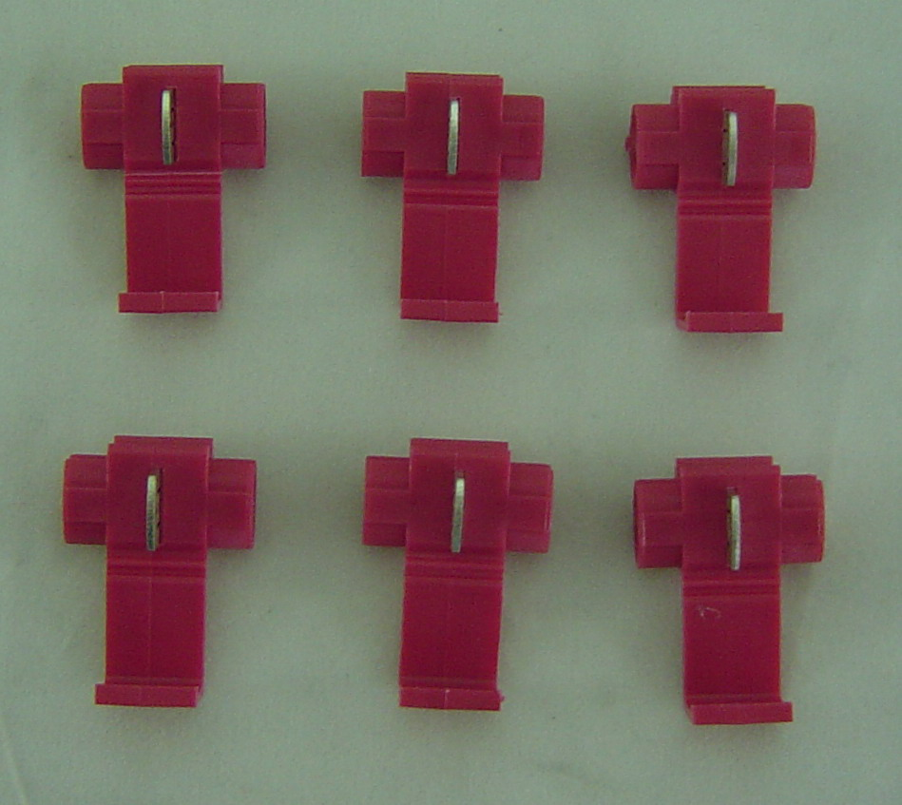

. | For 2 Doors Use:  2 x door sills with LED 2 x wire set 4 x stripping quick  lighted Panel & magnetic splice connector  control switch
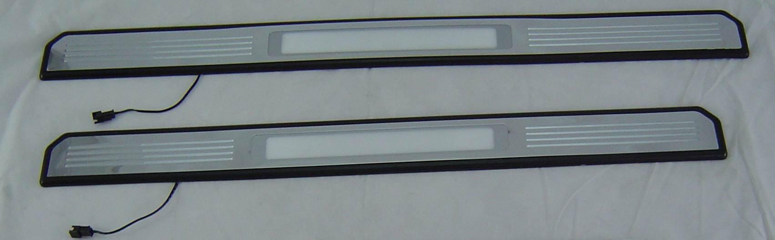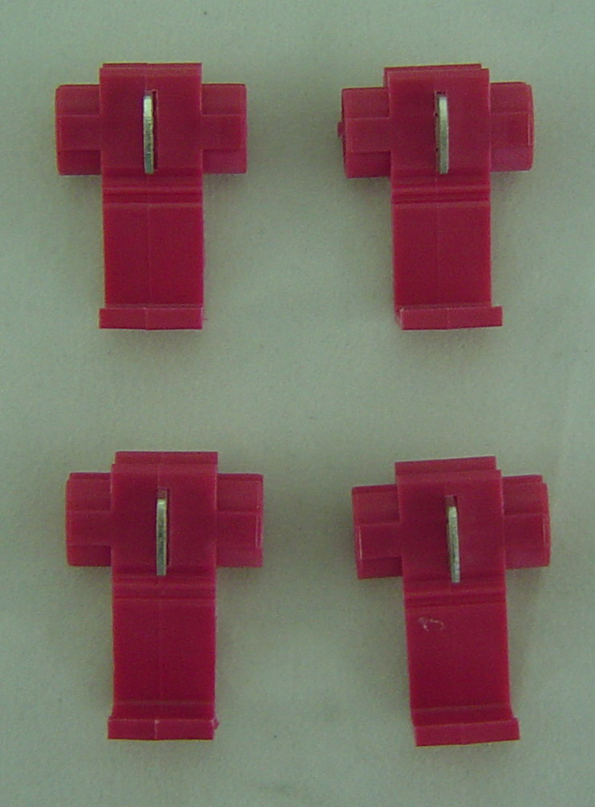
The installation circuit of door lighted sills:
- To seal the door sills with LED light onto the correct position of the door sills of the car then connect
the power red wire to B+ (To be suggested to find the car rear door wire set from the B pillar) and black
wire to door light switch ground ( - )
2. Now the door sills with light are installed completion.

